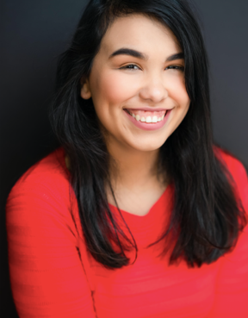 (210) 857-4619

AMANDA CIELO  
Vocal Shapeshifter/Actor/Singer

[amanda.sky19@gmail.com](mailto:amanda.sky19@gmail.com)

www.amandacielo.com

She/They | Soprano E3-E6 | 5’3 | Hair: Brunette

THEATRE:

THEORY OF RELATIVITY *Catherine*  Wright State Theatre

THE ADDAMS FAMILY *Grandma Addams* Wright State Theatre

IF/THEN *Ensemble/Ann (U/S)* Wright State Theatre

THE CURIOUS INCIDENT… *Voice #6 (U/S)*  Wright State Theatre

DRACULA, THE MUSICAL *Vampire Bride* North East School of the Arts

INTO THE WOODS *Baker’s Wife* Cameo Theatre

RENT *Joanne Jefferson* Cameo Theatre

FILM:

AN’YE HARM NONE *Principal Role* NEISD Cinema Student Production

SOFIA *Supporting Role*  NEISD Cinema Student Production

VOICEOVER:

THE SUNFLOWER AND THE ROSE *Rose*  Cosmic Intervention Media

TRAININGS:

Voice Over: Kiba Walker (VO Workshops, November 2023)

Wright State University, BFA Acting (Emphasis in Musical Theatre)

Voice: Jaime Cordes

Acting: Joe Deer, Greg Hellems, Josh McCabe, Marya Spring Cordes, and Bruce Cromer

Dance: Greg Hellems, Ashley Walton, Erin Robbins, Michelle Goodman, and Jeanette Popp

Voice/Speech: Deborah Thomas

CCM Prep Musical Theatre Intensive Program (2016)

SPECIAL SKILLS:

Languages: Spanish

Voice Impressions: Amy Winehouse, Disney Princess, Brittney Spears, and Female Cartoon Characters

*Vocal Demos ready upon request*